**Spring 2019**

**CSE 5330 – Database Systems 1**

**Project 2 Phase 2**

**Conceptual Schema Database Schema**

**Project Members:**

Balaji Gurumoorthy – 1001680348

Goutami Padmanabhan – 1001669338

**Professor:** Bhanu Chaturvedi Jain

**Honor Code**

I pledge, on my honor, to uphold UT Arlington's tradition of academic integrity, a tradition that values hard work and honest effort in the pursuit of academic excellence.

I promise that I will submit only work that I personally create or that I contribute to group collaborations, and I will appropriately reference any work from other sources. I will follow the highest standards of integrity and uphold the spirit of the Honor Code.





Balaji Gurumoorthy Goutami Padmanabhan

I pledge, on my honor, to uphold UT Arlington's tradition of academic integrity, a tradition that values hard work and honest effort in the pursuit of academic excellence.**Screenshots of results**

Question 1: Enter a country name (for example Brazil) in the interface, and then retrieve and display the Game ID, in which this team played, followed by the player name, who was in the starting lineup for this game, and the player no(player id) of the player. Let the records be sorted by the Game ID and Player no(Player id).

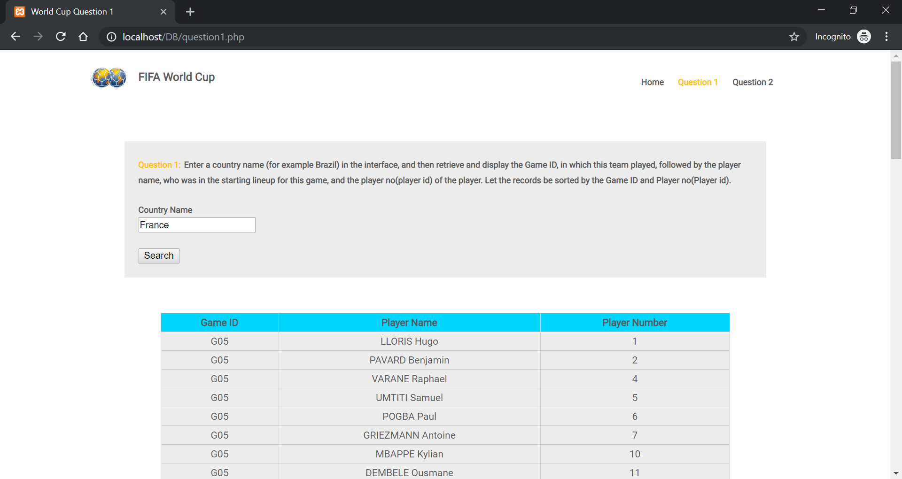

Question 2: Enter a country name (Russia, Brazil etc) and card color (Yellow, Red). Retrieve and display the GameId and the Player Name combination, such that the Player from that country played in that game and received a card of that color.

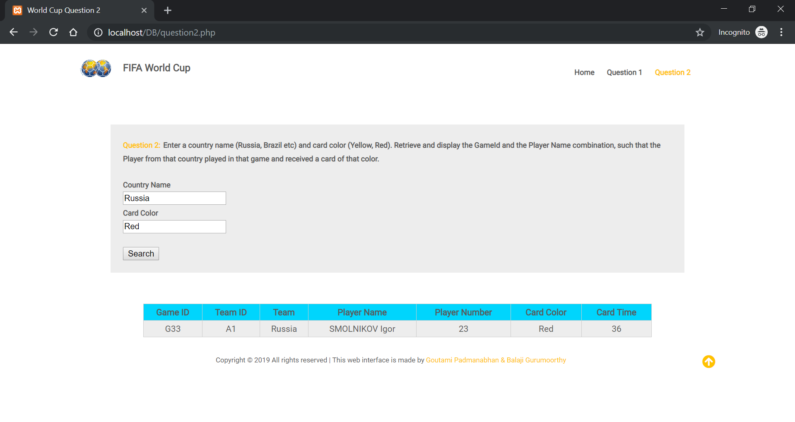

**Instructions to execute our code**

1) Place the DB folder attached in C:\xampp\htdocs

2) In XAMPP, Start Apache and MySql

3) Open a new incognito window and type "http://localhost/DB/index.php" in the address bar and access the web interface.